1.**HOME PAGE**

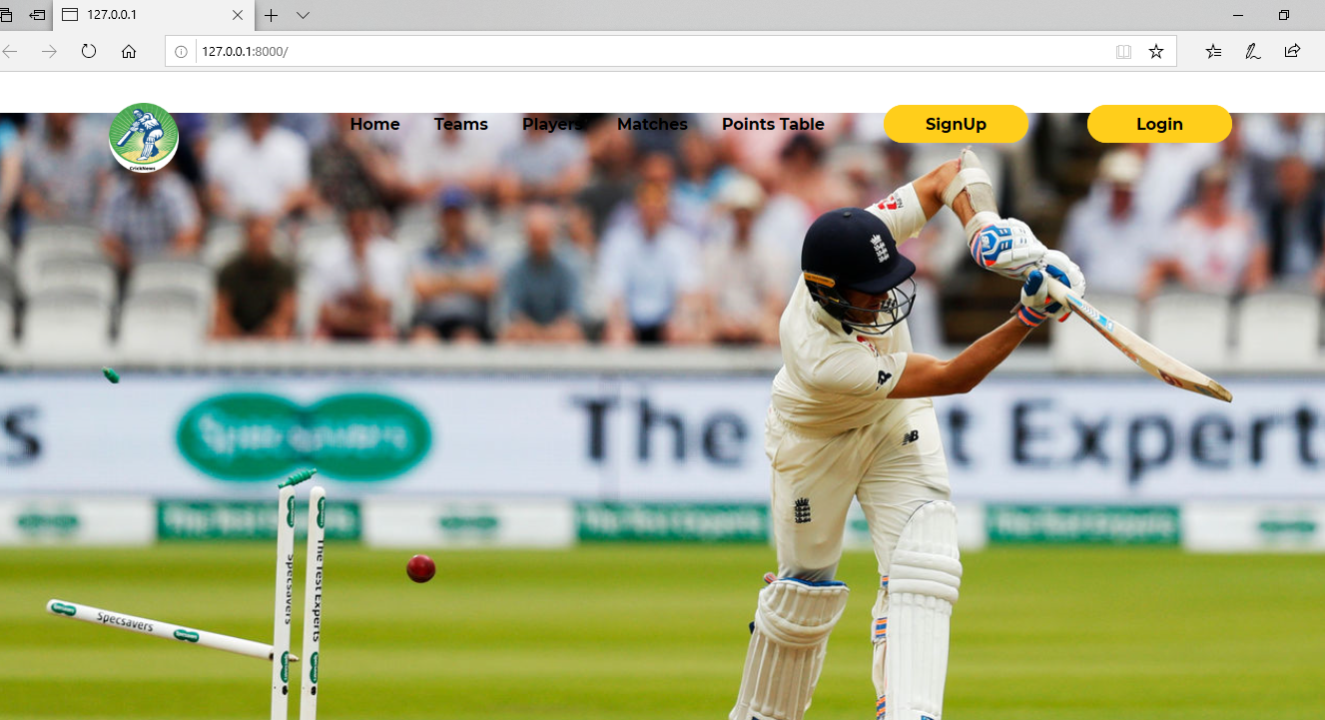

2.**ADMIN AUTH PAGE(**AT END OF USER HOME PAGE)

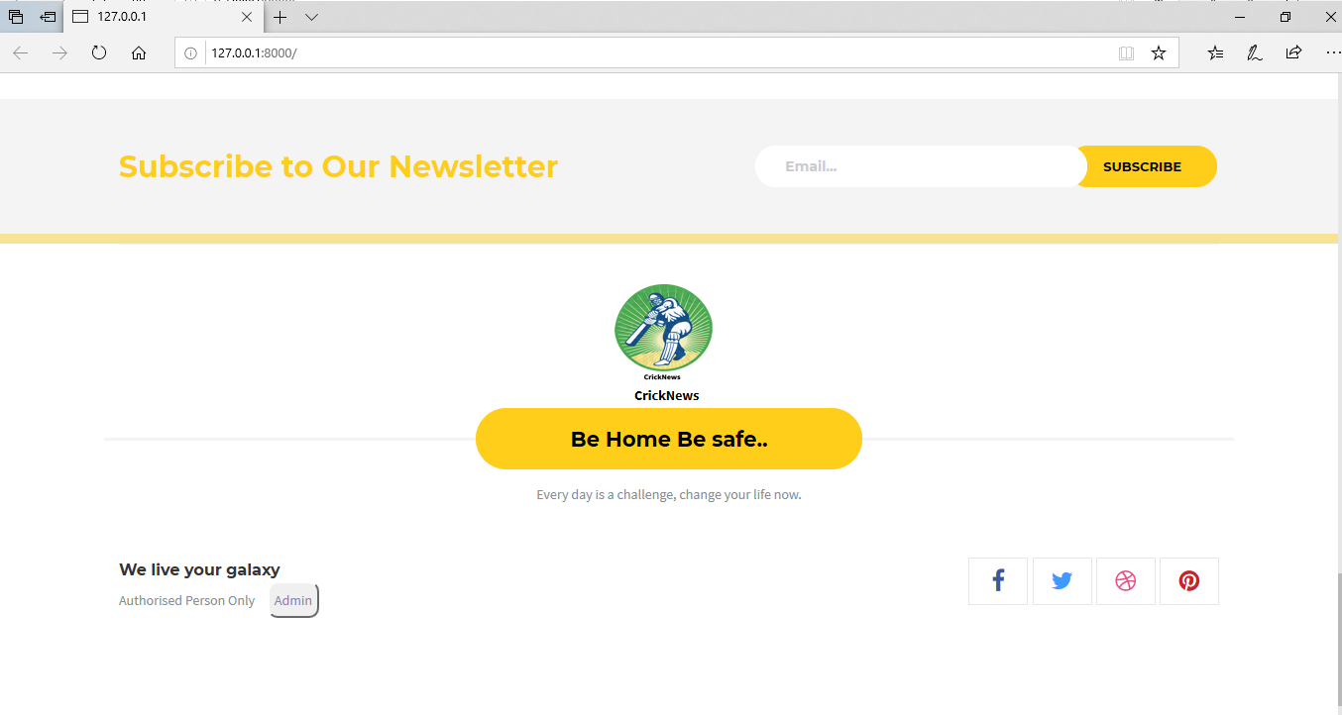

3.**ADMIN LOGIN PAGE( ADMIN NAME: admin , Password: admin)**

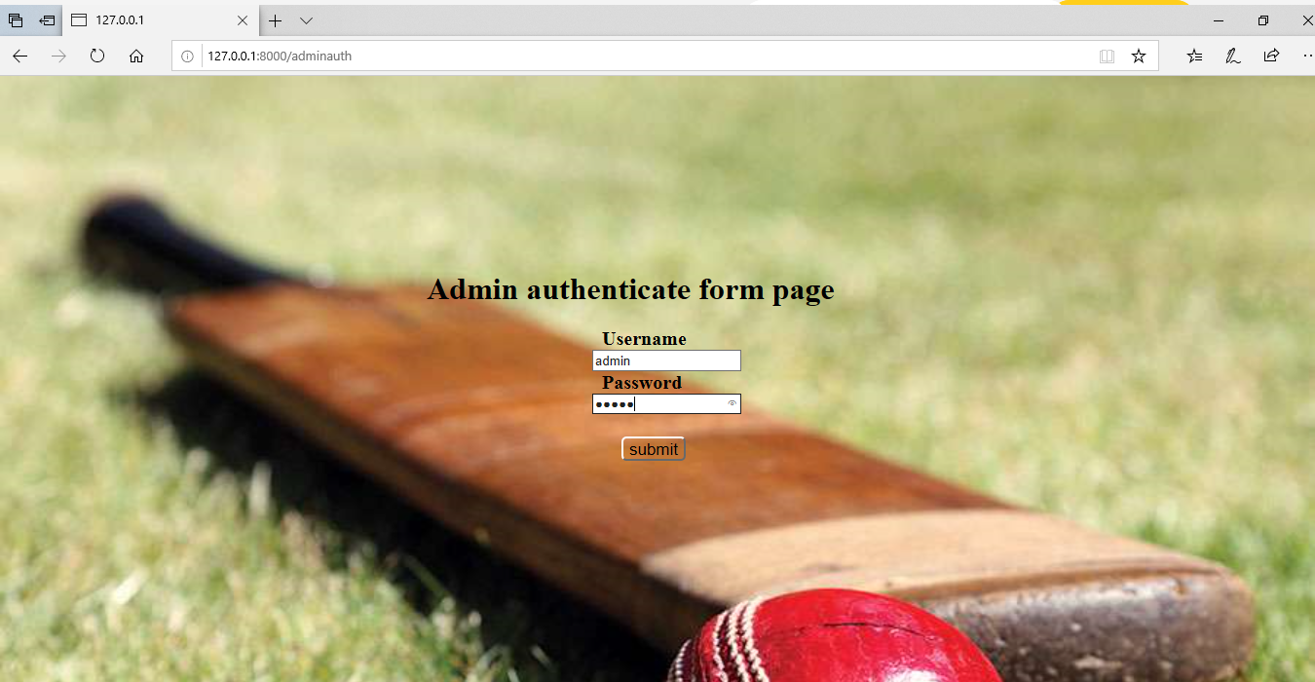

**4.Admin home page**

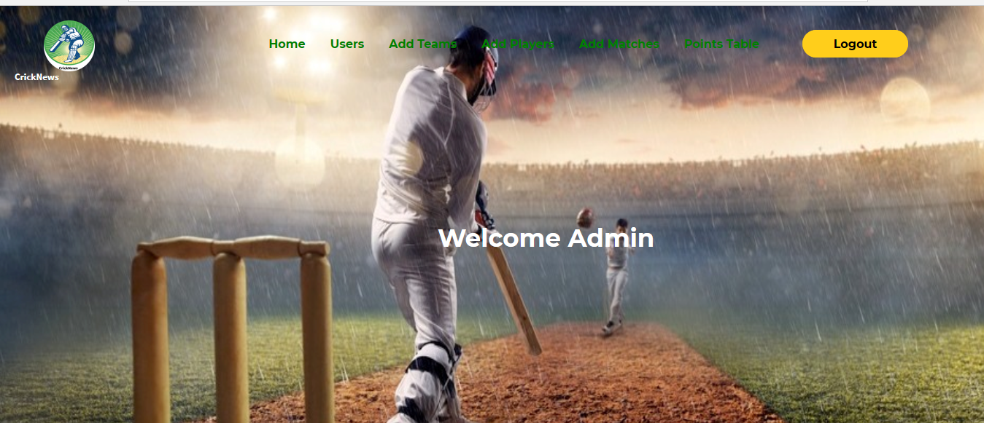

**5.Admin User Display**

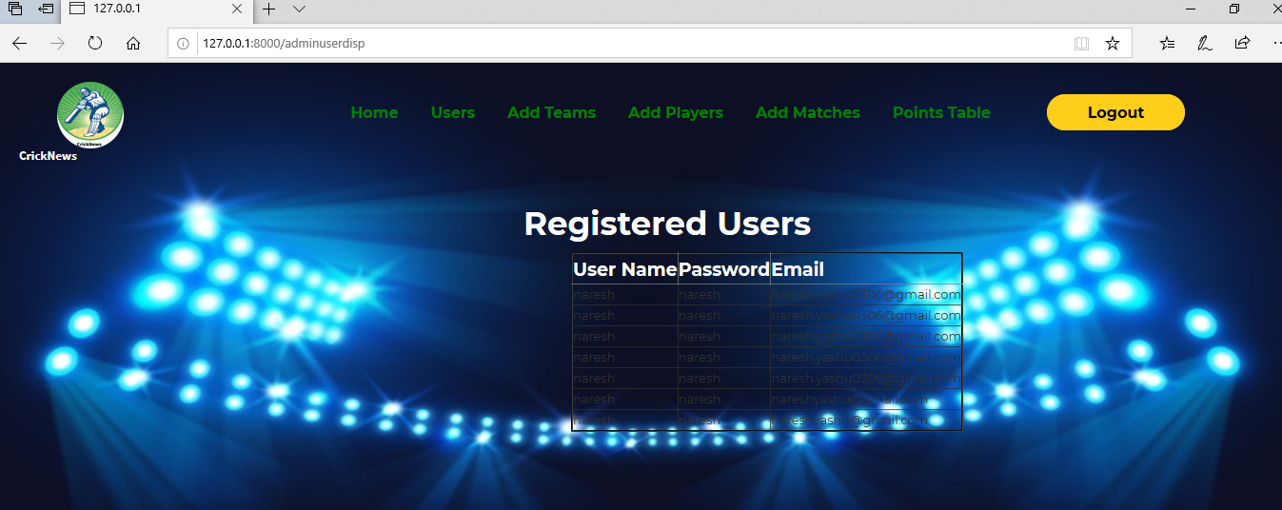

**6.Admin add teams**

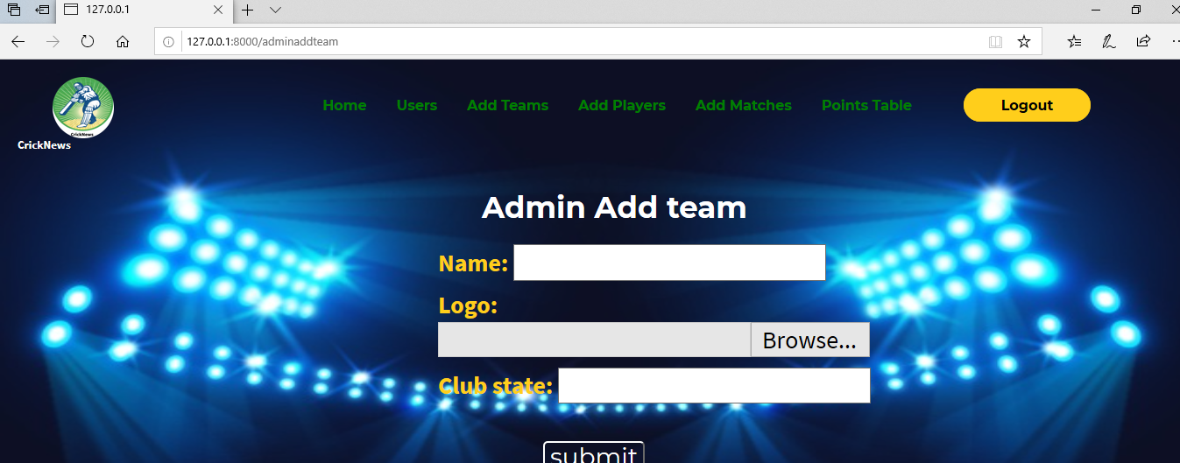

**7.Admin add team players**

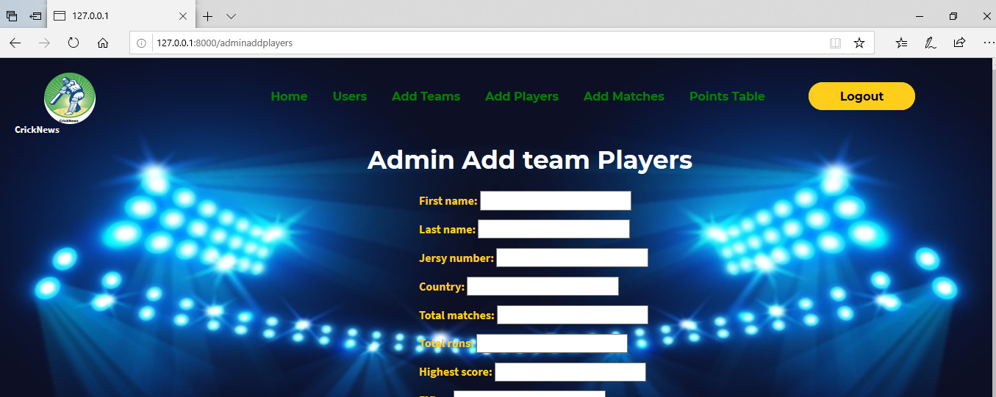

**8.admin add team matches**

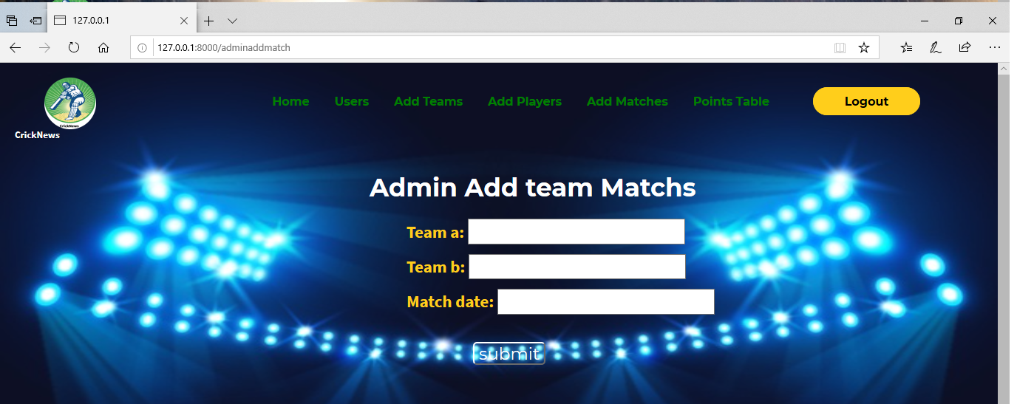

**9.Admin add points for the teams**

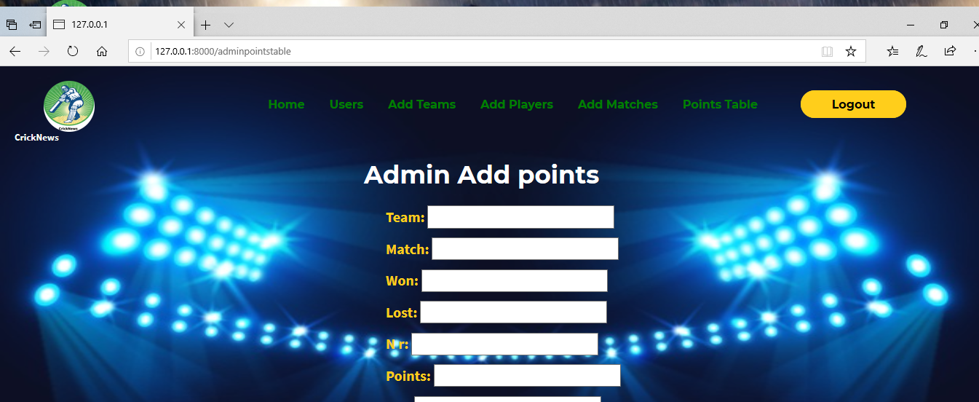

**10.User teams display**

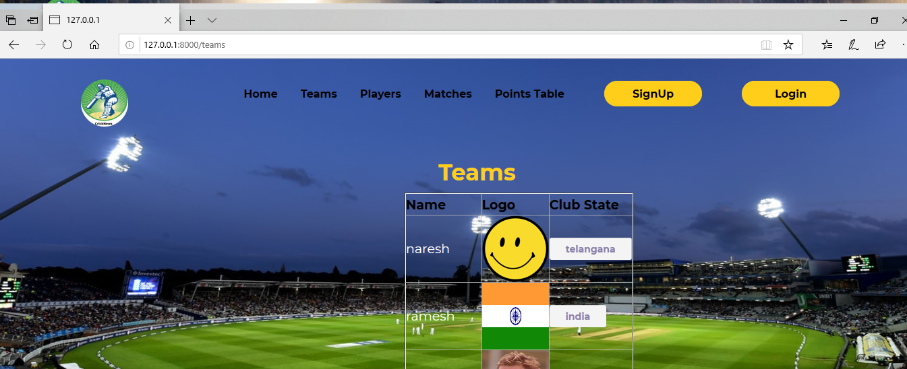

**11. individual Team players details**

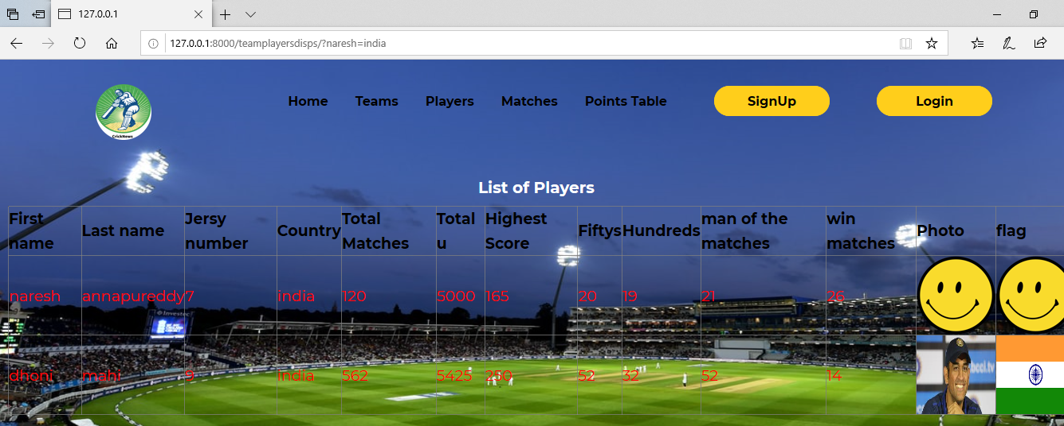

**12. Total players list**

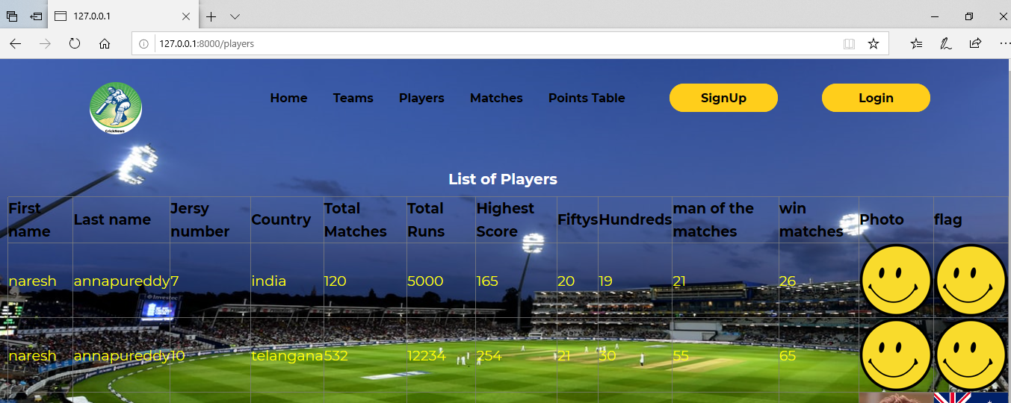

**13. Users page matches list**

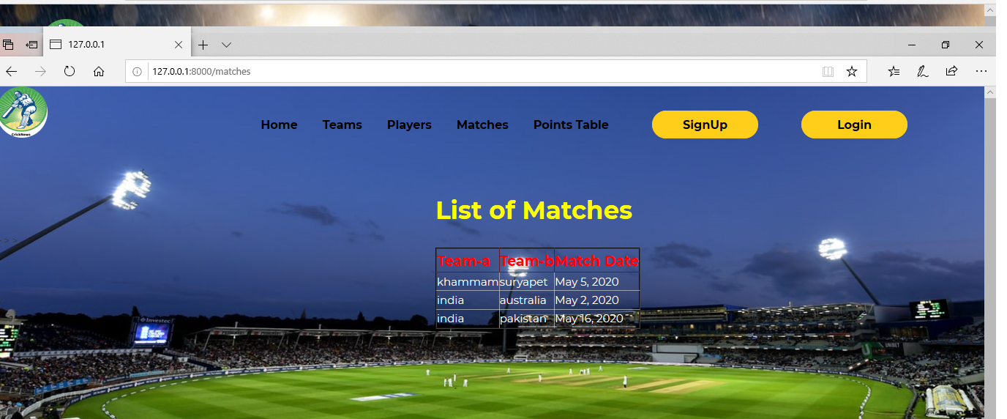

**14.User page points table display**

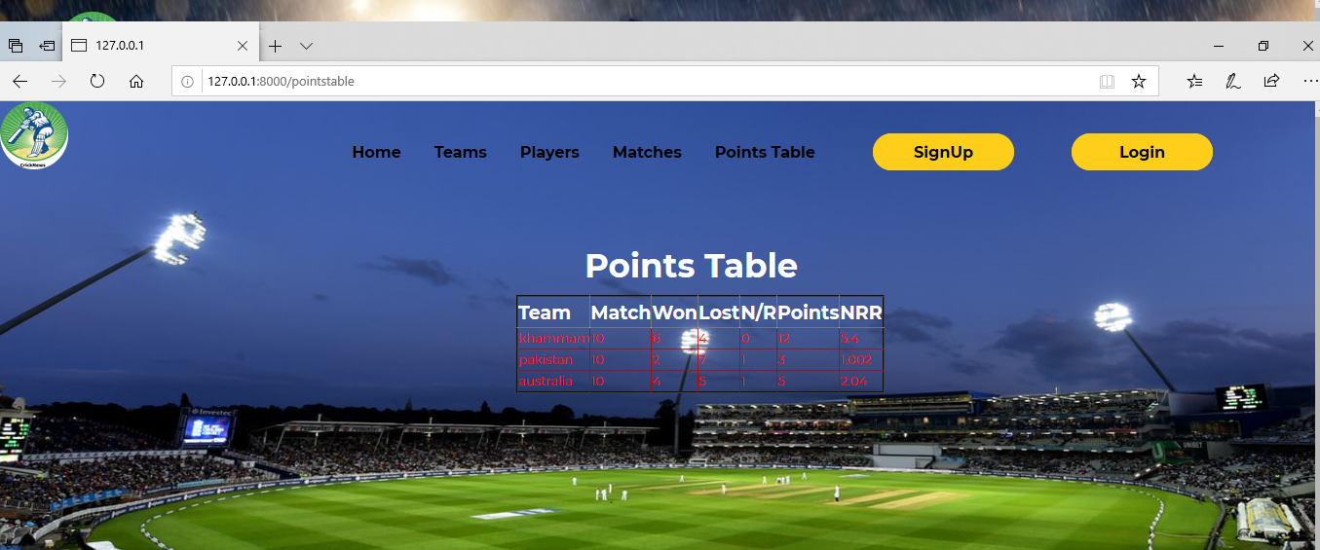

**15.signup page for user**

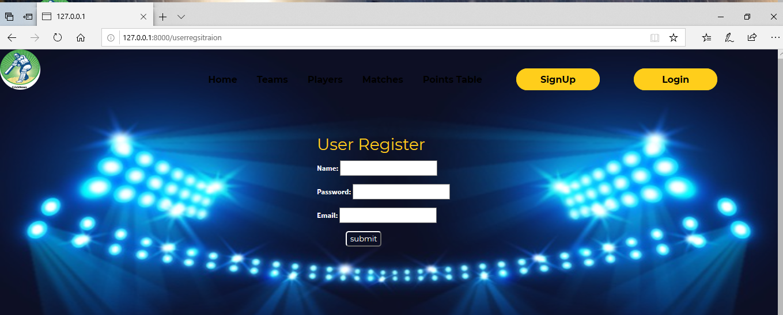

**16. Signin page for user**

